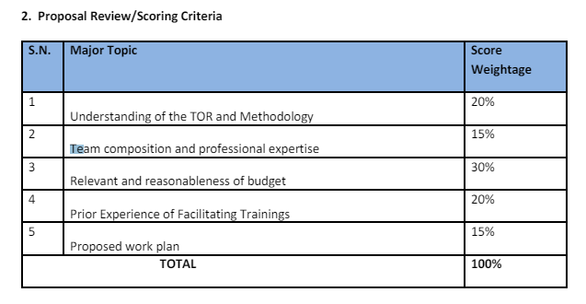

Evaluation criteria

Do you want to set Evaluation Criteria for this proposal?

yes/No ? if yes

Type of Evaluatin: QCBS, LCBS, FCBS, OTHER

Full Marks =>

Pass Marks =>

Technical Proposal Weightage = 80

Financial Proposal Weightage = 20

(TP + FP should be 100 validate form)

UI Design

https://codepen.io/sanjayojha/pen/qBONdVm

Similar UI Technical Proposal

|  |  |  |
| --- | --- | --- |
| Topic Name | Score | Remarks |
|  |  |  |
|  |  |  |
|  |  |  |
|  |  |  |
| Total | | 100 |

Note:

1. Total should be 100 when saving the data.
2. Please left parent_id null. We are not going to use it.
3. Need to add two column in tenders table tp_score_weight and fp_score_weight

**Submit Evaluation Criteria**

If already submitted show evaluation criteria. Allow to edit the evaluation until tender is published.

There should be an option to assign Evaluator. eg Assign Evaluator button

**Evaluation Process:**

table tender_evaluations

Evaluator Login:

After Evaluation Login:

Dashboard:

Evaluation

|  |  |  |  |  |
| --- | --- | --- | --- | --- |
| SN | Tender Title | Application Evaluation | Deadline | Status |
| 1 | Tender -00 | 5/10 (50%( | July 15, 2024 | Assigned/Completed |

Database: List of tender can be retrieve from evaluators table. Check where condition organization id and evaluator_user_id

Clicking into the Tender Name open tender details Page (No edit/delete allow)

Click into the Application Evaluation Link:

List of application will be listed here:

Download Evaluation

|  |  |  |  |  |  |
| --- | --- | --- | --- | --- | --- |
| SN | Applicant | TC Mark | Status |  | Action |
| 1 | Young Minds Creation Pvt Ltd | 80/100 | Pass |  | View |
| 2 | Softbiz infosys | 70/100 | Pass |  | View |

*Database: add obtain_mark decimal nullable column to*

Clicking into Download evaluation will download all the details in excel/pdf

View page

Enter your evaluation Mark

|  |  |  |  |  |
| --- | --- | --- | --- | --- |
| SN | Criteria | Full Mark | Obtain Mark | Remarks |
| 1 | C1 |  |  |  |
| 2 | C2 |  |  |  |
| 3 | C3 |  |  |  |
| 4 | C4 |  |  |  |
| 5 | C5 |  |  |  |
|  | Total | 100 | 80 |  |

Text Area Box:

Write your overall evaluation

Submit

Note: Obtain Mark should not access the Full Mark, Obtain mark should not accept negative value (0 should be accepted).

Do not allow to add/edit if the evaluation deadline is crossed